Quantum expertise
Quantum expertise is strategically important for businesses because it provides a significant competitive advantage through the ability to solve complex problems that are currently impossible or impractical for classical computers. Early investment in this area positions a company as a leader, allowing it to innovate, optimize operations, and create new revenue streams.
Quantum expertise is not about predicting the exact year of breakthrough. It’s about preparedness, credibility, and positioning.

🚀 Key Strategic Advantages
Having in-house quantum expertise gives you a first-mover advantage in a rapidly developing field. It enables your company to:
- Solve "Intractable" Problems: Quantum computers can tackle complex optimization and simulation problems with an exponential increase in computational power. This is particularly relevant for fields like logistics, finance, and materials science, where finding the best solution from countless possibilities can lead to massive cost savings and efficiency gains.
- Enhance AI and Machine Learning: Quantum computing can supercharge AI by accelerating the training of machine learning models and analyzing massive datasets in new ways, leading to more accurate predictions and powerful insights. This is a game-changer for data-driven industries.
- Create New Products and Services: Quantum technology isn't just about doing the same things faster; it's about enabling entirely new capabilities. This could mean developing novel drugs and materials, creating ultra-secure communication networks, or optimizing complex systems like urban traffic flow and power grids.
- Stay Ahead of Cybersecurity Threats: While quantum computers pose a threat to current encryption methods, quantum expertise is essential for developing and implementing quantum-safe cryptography. This proactively protects sensitive data and communications from future attacks, a critical consideration for any business.

💼 Industry-Specific Applications
The strategic value of quantum expertise is already being realized in a number of industries:
- Finance: Companies are using quantum algorithms for portfolio optimization, high-frequency trading, and risk analysis. The ability to model complex market scenarios and detect fraud in real-time offers a clear competitive edge.
- Healthcare and Pharmaceuticals: Quantum computing can revolutionize drug discovery by simulating molecular interactions at an unprecedented scale, dramatically shortening the R&D timeline. It can also improve medical diagnostics, optimize hospital logistics, and lead to truly personalized medicine.
- Logistics and Supply Chain: For companies like FedEx and DHL, quantum expertise can optimize complex routing problems, warehouse layouts, and delivery schedules, leading to significant reductions in cost and fuel consumption.

Quantum: Risk & Opportunity Matrix
⚠️ Risks if Unprepared:
- Cybersecurity exposure (Q-Day)
- Competitive lag in finance, pharma, logistics
- Talent scarcity & dependency on vendors
🚀 Opportunities with Expertise:
- Early adoption of post-quantum cryptography
- Quantum-inspired optimization & innovation
- Attractive position for partnerships & top talent

Executive Takeaway
Quantum expertise = Preparedness, credibility, positioning.
- Like AI, quantum will shift from 'future tech' to 'business necessity' fast.
- Firms with expertise will capitalize first.
- Others face late-mover disadvantage and higher risks.

Corporate Adoption

Understand the imperative
- Hard decision: To jump now on the bandwagon or to lose against their competitors?
- BCG and McKinsey are the most vocal analyst shops on this.(BCG started to promote in 2021 the “it’s not an if but a when”)
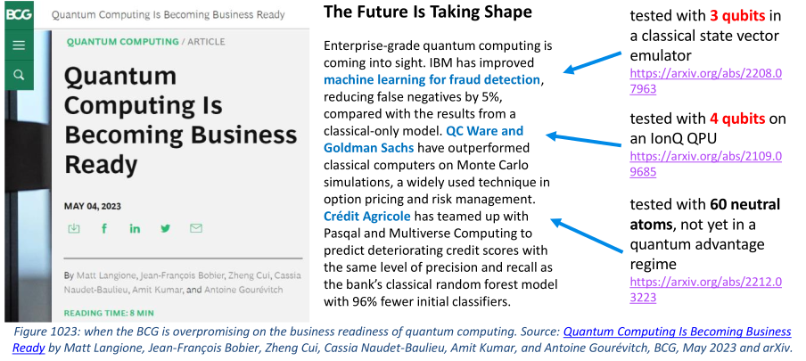Despite all the required prudence that is mandated here, there are several reasons why, still, corporations should evaluate quantum technologies:
  - They need to build some understanding of the trend, the buzz and the technology.
  - Building a small workforce around quantum technologies is an excellent to attract high-level and skilled talent with a lot of potential.
  - Investing in quantum technologies is not just about quantum computing but deals with other technologies like quantum sensing and quantum communications which are more mature than quantum computing.
  - As the quantum threat on current public key cryptography is also part of the buzz, it has to be factored in. Even though this threat is largely exaggerated, many cryptography legacy infrastructures will need to be upgraded, pushed by standardization and, sometimes, government regulations.
  - Working on quantum computing is an excellent way to revisit classical computing solutions. All the fuss on quantum computing potential benefits is creating a strong emulation with classical computing specialists, whether it works or not.

Technology screening
- No need to adopt any new technology after reading a news clip.
- start with looking at the various use cases of quantum technologies and what added value it could potentially bring to a business. (See 1011-1135 in refX)
- understand the technological dimensions of quantum computing and related telecommunications and cryptographic matters
- Don’t miss the potential of quantum sensing. It may be enormous in various industries where precision is mandated
- Learn how to decode analysts, research labs and vendors lingua, particularly in the field of over-promises.
- Attend ecosystem events such as the QC Ware Q2B conference, Lab Quantique meet-ups, or
quantum business conferences that are now organized all around the world.

Needs analysis
- Identify intractable problems in the company's applications and business needs portfolio
- look at the related case studies, existing algorithms that are supposed to solve these problems. Understand the scope of existing case studies
- Create an internal community of engineers and business specialists interested in quantum technologies,
- Launch a mapping of security protocols threatened by quantum computers
- Look at what your peer companies and those from your own ecosystem are doing with quantum technologies

Training
- Train a few developers in quantum programming.
- Understand the links between quantum computing and artificial intelligence.

Evaluation
- Talk to the many quantum computing independent software vendors
- Test some algorithms in the cloud with universal quantum computers (IBM, AWS and Microsoft cloud, OVHcloud, etc) or quantum annealer (D-Wave) or with emulators (Quirk, Eviden, IBM, Microsoft, AWS, Google).
- Do not hesitate to test algorithms on D-Wave quantum annealers despite their relatively poor image among universal quantum computer purists.
- Keep an eye on analog quantum simulations which are useful for solving several classes of problems: quantum materials simulations, complexity problems and some machine learning problems.
- Avoid the do nothing approach

